Data handling graphs
Name: C. Karthik
Register no: 192573008

Q1. Bar chart
import matplotlib.pyplot as plt

categories = ["Groceries", "Dairy", "Fruits", "Vegetables", "Bakery",
"Beverages", "Snacks", "Personal Care",
"Household Items", "Frozen Foods"]

sales = [120, 95, 80, 75, 68, 90, 110, 55, 70, 60]

plt.figure(figsize=(10,6))
plt.bar(categories, sales, color='skyblue')
plt.title("Monthly Sales Revenue by Product Category")
plt.xlabel("Product Category")
plt.ylabel("Sales (₹ Lakhs)")
plt.xticks(rotation=45)
plt.tight_layout()
plt.show()

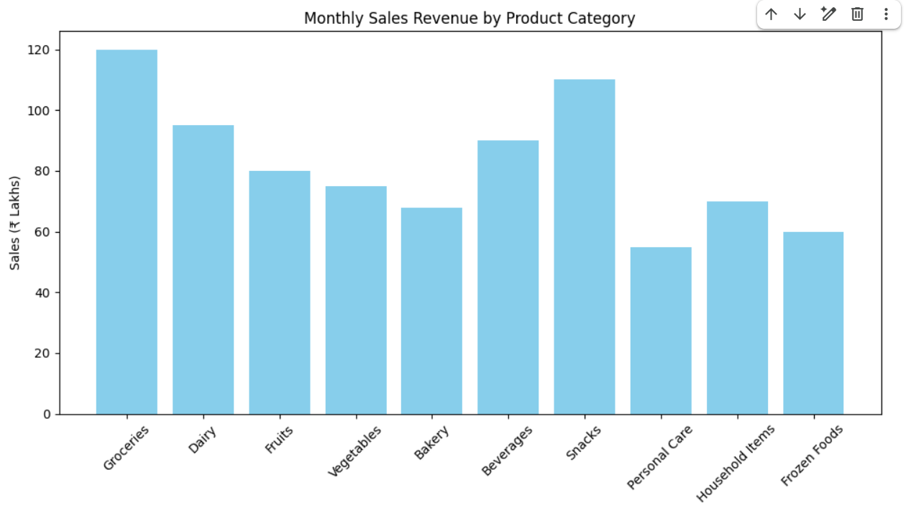
Q2. Histogram
import matplotlib.pyplot as plt

salary = [3.2,4.5,5.0,6.8,7.2,8.5,4.8,5.5,6.0,7.8,9.2,10.5]

plt.figure(figsize=(8,5))
plt.hist(salary, bins=5, color='green', edgecolor='black')
plt.title("Distribution of Salary Packages")
plt.xlabel("Salary Package (LPA)")
plt.ylabel("Number of Students")
plt.show()

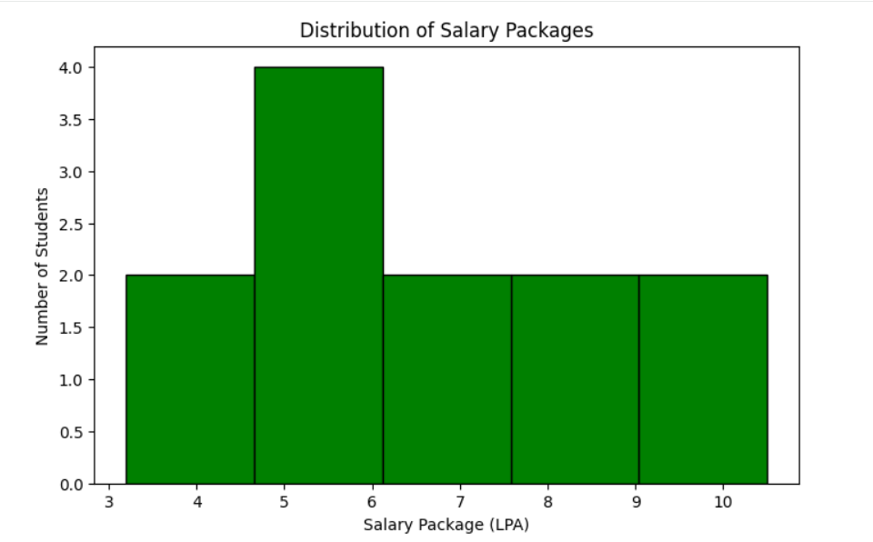
Q3. Pie chart
import matplotlib.pyplot as plt

labels = ["Social Media","Television","Print Media","Radio",
"Email Marketing","Influencer Marketing","SEO","Events"]

budget = [28,22,10,8,12,9,6,5]

plt.figure(figsize=(7,7))
plt.pie(budget, labels=labels, autopct="%1.1f%%", startangle=90)
plt.title("Marketing Budget Allocation")
plt.show()
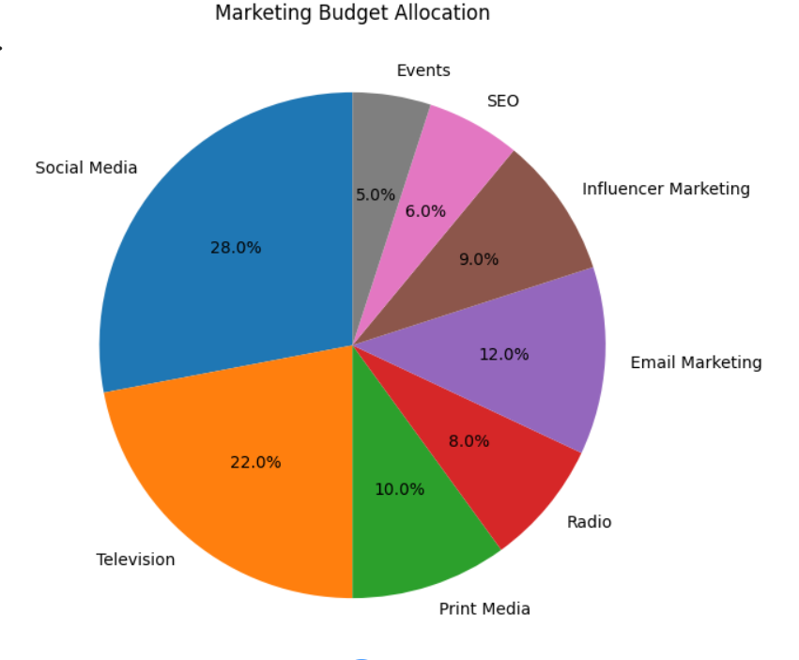
Q4. Scatter plot
import matplotlib.pyplot as plt

advertising = [5,8,10,12,15,18,20,22,25,28]
sales = [42,55,63,70,82,91,98,110,120,132]

plt.figure(figsize=(8,5))
plt.scatter(advertising, sales, color='red', s=80)
plt.title("Advertising Cost vs Sales Revenue")
plt.xlabel("Advertising Cost (₹ Lakhs)")
plt.ylabel("Sales Revenue (₹ Lakhs)")
plt.grid(True)
plt.show()

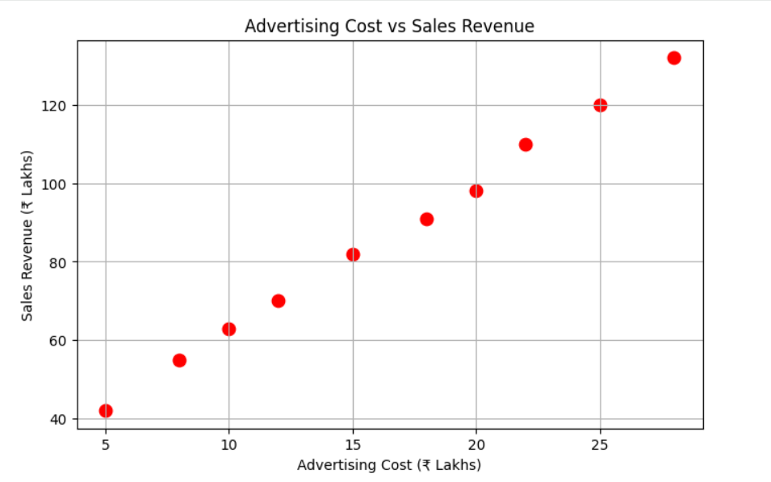

Q5. Line chart
import matplotlib.pyplot as plt

months = ["Jan","Feb","Mar","Apr","May","Jun",
"Jul","Aug","Sep","Oct","Nov","Dec"]

energy = [420,450,490,530,560,600,580,590,610,630,590,540]

plt.figure(figsize=(10,5))
plt.plot(months, energy, marker='o')
plt.title("Monthly Electricity Generation (2025)")
plt.xlabel("Month")
plt.ylabel("Energy Generated (MWh)")
plt.grid(True)
plt.show()